**HOSTEL MANAGEMENT SYSTEM**

**END TERM REPORT**

***by***

***1.ARYAN GUPTA***

***2.PRIYANSHU DWIVEDI***

***3.RUPESH LAKSHMAN***

**Section: K19SD**

**Roll Numbers:**

***1.ARYAN GUPTA - 32***

***2.PRIYANSHU DWIVEDI - 07***

***3.RUPESH LAKSHMAN - 12***

**UNIVERSITY LOGO :**



### **Department of Intelligent Systems**

**School of Computer Science Engineering**

**Lovely Professional University, Jalandhar**

**03 ( MARCH )** - 2020

## Student Declaration

**This is to declare that this report has been written by me/us. No**

**part of the report is copied from other sources. All information**

**included from other sources have been duly acknowledged. I/We**

**aver that if any part of the report is found to be copied, I/we are**

**shall take full responsibility for it.**

**Signature of Student : ARYAN**

**Name of Student : ARYAN GUPTA**

**Roll number : 32**

**Place : UTTAR PRADESH**

**Signature of Student : PRIYANSHU**

**Name of Student : PRIYANSHU DWIVEDI**

**Roll number : 07**

**Place : UTTAR PRADESH**

**Signature of Student : RUPESH LAKSHMAN**

**Name of Student : RUPESH LAKSHMAN**

**Roll Number : 12**

**Place : ANDHRA PRADESH**

**Place : UTTAR PRADESH**

#### TABLE OF CONTENTS

**TITLE** **PAGE NO.**

1. **Background and objectives of project assigned ................** **1**

**1.1.....INTRODUCTORY DESCRIPTION.............................** 1

* + 1. **... ----------------------------------------------...........................** **3**
    2. **........MOTIVATION..........................................................** **5**
  1. **.....OUTCOME OF PROJECT.......................................** 7
     1. **…..--------------------------------------...................................** **7**
     2. **.......CONCRETE GOALS................................................** **9**
     3. **..........OBJECTIVE...........................................................** **10**

1. **Description of Project ... ........................................................** **14**
   1. **..........................................................................................** **17**
   2. **..........................................................................................** **18**

**BONAFIDE CERTIFICATE**

**Certified that this project report**

**“ HOSTEL MANAGEMENT SYSTEM”**

**is the bonafide work of " ARYAN GUPTA , PRIYANSHU DWIVEDI , RUPESH LAKSHMAN” who carried out the project work under my supervision.**

**<<Signature of the Supervisor>>**

**<<Name of supervisor>>**

**<<Academic Designation>>**

**<<ID of Supervisor>>**

**<<Department of**

**<<Supervisor>>**

**\* Introduction of the project:-**

**================================**

**In the fast changing world, information technology and information management are going to play an important role. We are living in the computer age during past spome year.**

**The computer has gaining popularity. Computer revolution founds its way into almost every aspects of human life and living. A computer is admirably suited to handle any information**

**and hence is an information processor that is, it can recieve data, perform some basic operations on that data and produces results according to predetermined program.**

**BACKGROUND AND OBJECTIVES**

===============================================

Top of Form

### **Objective of the Project**

**As the name specifies “HOSTEL MANAGEMENT SYSTEM” is a software developed for**

**managing various activities in the hostel.**

**For the past few years the number of educational institutions are increasing rapidly.**

**Thereby the number of hostels are also increasing for the accommodation of the students studying in**

**this institution. And hence there is a lot of strain on the person who are running the hostel and**

**software’s are not usually used in this context.**

**This particular project deals with the problems on managing a hostel and avoids the problems which**

**occur when carried manually. Identification of the drawbacks of the existing system leads to the**

**designing of computerized system that will be compatible to the existing system with the system**

**Which is more user friendly and more GUI oriented.**

**We can improve the efficiency of the system, thus overcome the drawbacks of the existing system.**

* **Easy to handle**
* **Easy data updating**
* **Easy record keeping**

**Description of the project :**

**=============================================**

**PICTORIAL FLOW OF PROJECT**

|  |
| --- |
| With basic html and css we started to design the basic layout to my page ….. |

|  |
| --- |
| **As per our question we completed the layout of our page .**  **Created tables and forms regarding to our website.** |

|  |
| --- |
| **We selected lpu logo and different hostel related images as ou background images in our websites..**  **For this we used the property of css.** |

|  |
| --- |
| **We created two login pages in our website one for login and the other is for registration and a table of content to enter the data….** |

|  |
| --- |
| **At final we created hyperlinks to open the two login pages in**  **This is our final approach….** |

**WORK DIVISION AMONG STUDENTS**

1. **HERE WE DIVIDED THE TOTAL WORK AMONG OURSELVES BY WRITING THE CODE OF BASIC LAYOUT OF OUR WEBSITE BY ONE .**
2. **WRITING DOWN THE CSS CODE OF THE SAME BASIC LAYOUT OF WEBSITE BY OTHER AND SELECTING THE REQIRED BACKGROUND IMAGES ARE ASLO SELECTED BY THREE OF US…**

**3. AT LAST THE LOGIN PAGES AND REGISTRATION PAGES OF OUR WEBSITE WERE CREATED THE THIRD ONE INCLUDING THE LINKS REQUIRED TO OPEN THEM.**

**4 . WE DECIDED TO ADD DIFFERENT BACKGROUND IMAGES FOR DIFFERENT PARTS SUCH AS FOR HEADER , FOOTER , BODY , AND FOR SECTION …………..**

**IMAGES OF OUR WEBSITE**

**=================================================**

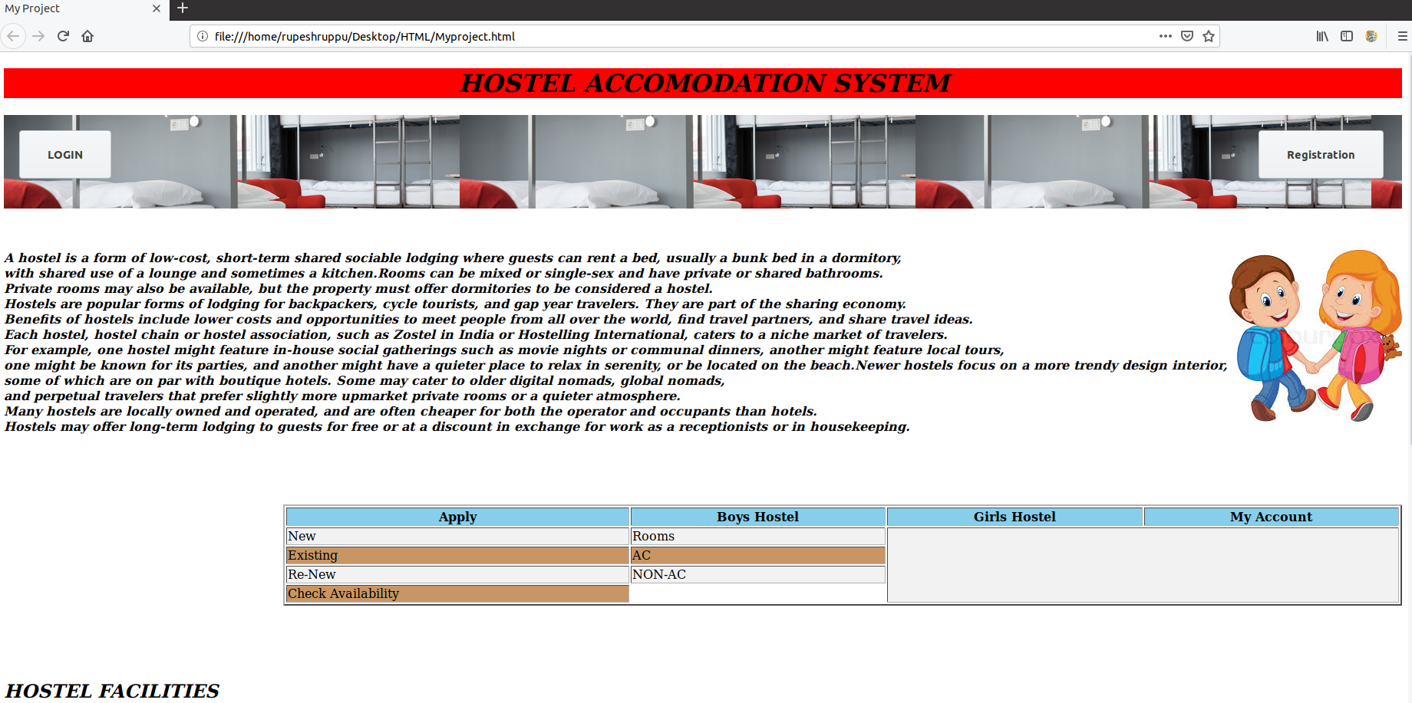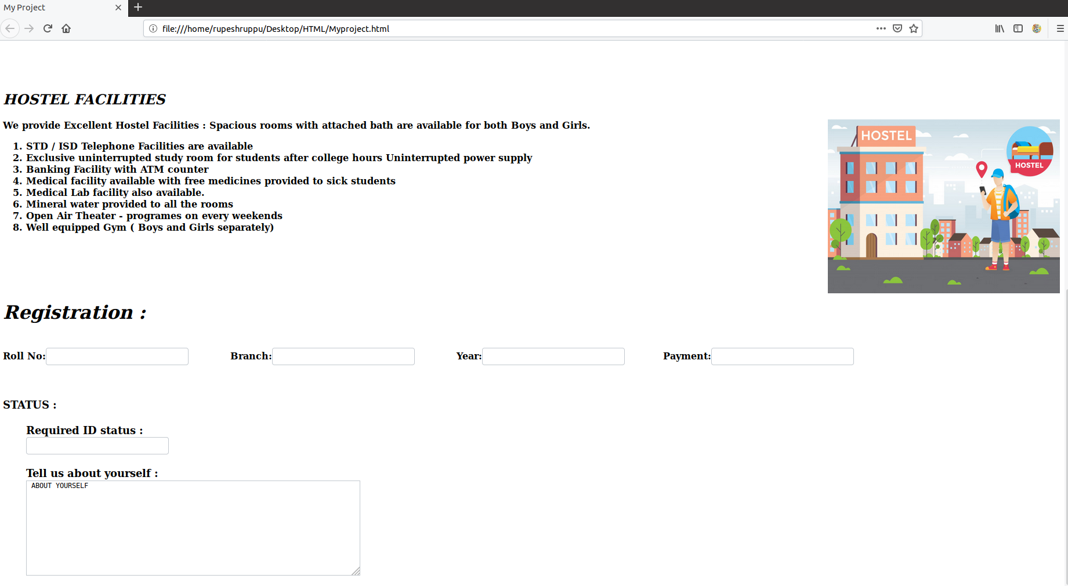

**TECHNOLOGIES AND FRAMEWORK WE DID :**

**1. BASICALLY WE COMPLETED OUR PROECT BY TAKING THREE LANGUAGES INTO CONSIDERATION**

**a . HTML:-**

**Hypertext Markup Language is the standard markup language for documents designed to be displayed in a web browser.**

**It can be assisted by technologies such as Cascading Style Sheets and scripting languages such as JavaScript**

**CSS:-**

**CSS stands for Cascading Style Sheets. CSS describes how HTML elements are to be displayed on screen, paper, or in other media.**

**CSS saves a lot of work. It can control the layout of multiple web pages all at once.**

**JAVASCRIPT:-**

**A JavaScript function is a block of code designed to perform a particular task.**

**A JavaScript function is executed when "something" invokes it.**

**2. WE DID OUR PROJECT BY REFFERING TO DIFFERENT ONLINE PLATFORMS SUCH AS REFFERING TO WEBSITES AND LOOKING SOME VIDEOS FROM YOUTUBE ………**

**3. WEBSITES SUCH AS**

**a. w3schools**

**b. tutorials point**

**c. php tutorials.com**

**SWOT ANALYSIS OF OUR PROJECT**

**STRENGTHS :**

**OUR BASIC STRENGTH IS THAT WE KNOW HOW TO WRITE DOWN THE BASIC CODE FOR HTML AND CSS.**

**WE DID IT AND WE ALSO CREATED THE LAYOUT FOR OUR WEBPAGE AND LOGIN PAGES AND REGRISTRATION PAGES RESPECTIVELY………..**

**WEAKNESS :**

**AT FIRST WE DON’T KNOW HOW TO WRITE THE CODE FOR SOME CONTENTS SUCH AS CREATING HYPERLINKS TO OPEN THE LOGIN AND REGISTRATION PAGES RESPECTIVELY…………...**

**AFTER REFFERING TO CERTAIN WEBSITES WE DID IT…**

**-------------------------- END --------------------------**